activity

1. What are the first 5 websites in your web history? (Ask your partner some questions about these)

2. Which browsers do you use? Which is your favourite? Why?

3. Which device do you mainly use to surf the internet?

4. Do you ever listen to podcasts? What was the last podcast you listened to about?

5. Would you prefer to read a paper book or an e-book? What was the last e-book you read?

Task:

Have a conversation with a partner

using the questions

All in English

Ask follow up questions!

* two Zoom page, google : It's good to have a lot of information, ~~~

**Data Communication**

~~Match verbs with nouns to make collocations:~~

|  |  |
| --- | --- |
| 1. ~~Follow H~~ 2. ~~Take part in d~~ 3. ~~Stream a, d~~ 4. ~~Update c, f~~ 5. ~~Post a, e, g~~ 6. ~~Download a, d, e~~ 7. ~~Browse f, e~~ 8. ~~Enter b~~ | 1. ~~Video~~ 2. ~~A password~~ 3. ~~Your status~~ 4. ~~A webinar (a web seminar)~~ 5. ~~Photos~~ 6. ~~Web pages~~ 7. ~~A comment~~ 8. ~~A link~~ |

~~Listen and answer:~~

1. ~~Does the IT specialist help the customer solve his problem? yes~~
2. ~~What does the caller like about the new browser? He can see all the bookmarks~~

~~Listen again:~~

1. ~~What IT has changed in the company?~~
2. ~~What three things does the caller need help with?~~
3. ~~Where are the menus?~~

Web Addresses:

|  |  |  |
| --- | --- | --- |
| Dash  Dot  Equals | Backslash  Forward slash | Question mark  Underscore |

시험나옴

**What is a Network?**

|  |
| --- |
| area / network / server / wireless / client-server / local / address / wide / connection / browser |

A network is a group of linked computers or other devices. There are two kinds of networks that are in common use.

In local area Networks (LANs) computers are close together – perhaps in the same building. They might be connected directly to each other by cable or through a wireless network such as wi-fi. In contrast, wide area networks (WANs) cover a larger area and usually use telephone lines or a mobile phone system to connect. A LAN can be a part of a WAN.

There are different types of wired networks. ***One*** is a star system. In ***this***, each computer (or other device) is connected to a central server. ***Another type*** is a ring system. This is a network that has each computer linked to two others. In a bus system there is a central cable which is called a bus, and each computer is linked to ***it***. Some large networks use a mesh. In ***this***, each computer is linked to several others. ***This*** has one big advantage: if one connection breaks, the data can use other connections. Therefore, it is difficult to break a mesh network.

Many networks work on a client-server system. In this, servers are special computers that store data, serve websites and have other similar functions. Generally, a client program will ask the server for data and the server will then send the data back to the client. For example, when you type a web address into a browser, the browser (the client) will ask the server for a web page, which then sends the web page back.





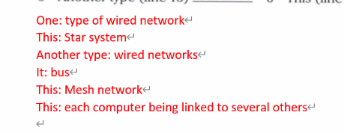

Label the diagrams:



1. **Ring**
2. **Star**
3. **Mesh**
4. **bus**

**Mobile Computing**

~~Complete the flowchart:~~

1. ~~Admin staff (Office workers) print out work instructions => 1~~
2. ~~Admin staff send invoice (paper showing cost of something) asking for payment => 6~~
3. ~~Client signs paperwork => 4~~
4. ~~Technician finds client and installs system => 3~~
5. ~~Technician picks up instructions => 2~~
6. ~~Technician takes paperwork back to office => 5~~

~~~~

~~How will the above flowchart change if the technician has a mobile device? Listen and draw a new flowchart to record this situation.~~

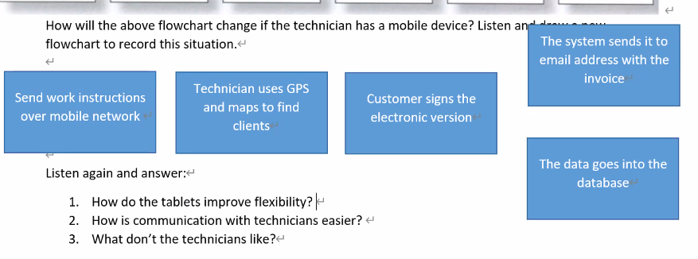

~~Listen again and answer:~~

1. ~~How do the tablets improve flexibility? If a customer changes their order, they can tell the technician easily~~
2. ~~How is communication with technicians easier? If they need spare parts, they order directly~~
3. ~~What don’t the technicians like? ~~

|  |
| --- |
| Language: Zero Conditional  Review: First conditional is used to talk about future results:  Pattern**:** If + present simple, will + (original) verb  If you click on this icon, a window will appear.  The zero conditional is used to talk about something that **usually** or **always happens** as a result of an action or situation. It describes **facts**.  Pattern**:** If /When+ present simple, present simple  If you drop a tablet, it breaks / First conditional : If you drop a table, it will break.  If you use a tablet, you can send documents easily. |

If/When:

If: the situation may or may not happen

When: the situation is expected / the situation will probably happen

When I get 100% on a test, I ~~will~~ eat 삼겹살

~~If~~ / when the sun rises, the alarm goes off

If you want to use the computer for a long time, clean the computer regularly.

A

Zero Conditional Practice

1. if / wild / are / scared / . / bite / they / animals

_____________________________________________________

1. if / get / too / eat / much / , / you / . / you / fat

_____________________________________________________

1. if / beach / go / . / the / sunscreen / should / you / to / you / take

_____________________________________________________

1. if / doesn't / oxygen (O2) / burn / no / paper / there / . / is

_____________________________________________________

1. if / big / need / . / you / a / have / family / , / you / a / car / big

_____________________________________________________

Complete the following assuming the entertainment system installation company uses mobile devices:

1. With the tablets, if the technician _________ (not know) the way to a job, he or she _________ (use) GPS to find the best way there.
2. If the customer ___________ (be) happy with the job, he or she ___________ (sign) using the tablet’s screen.
3. If a customer ___________ (change) their order, the system ____________ (update) the details on the tablet.
4. If a technician ___________ to order a new part, he or she ___________ a message electronically.

Zero Conditional Quiz

1. What do you do when you wake up late?

_____________________________________________________

1. What do you do if your internet doesn’t work?

_____________________________________________________

1. What do you do when you feel a cold starting?

_____________________________________________________

1. What do you do if you need to wake up early?

_____________________________________________________

1. What do you do if you are bored?

_____________________________________________________

1. What do you do when you can’t sleep at night?

_____________________________________________________

1. ____________________________________

_____________________________________________________

1. ____________________________________

_____________________________________________________

1. ____________________________________

_____________________________________________________

Discussion Questions (Internet)

1. What are 3 interesting websites you have bookmarked? (Ask your partner some questions about these)
2. Which browsers do you use? Which is your favourite? Why?
3. Which device do you mainly use to surf the internet?
4. Do you ever listen to podcasts? What was the last podcast you listened to about?
5. Would you prefer to read a paper book or an e-book? What was the last e-book you read?